MOST WORSHIPFUL PRINCE HALL GRAND LODGE OF FREE AND ACCEPTED MASONS OF MARYLAND AND ITS JURISDICTION, INC.
The Most HONORABLE Kevin L Barney JR., MWGM
RW Harold Robinson, RDDGM
RW Duron Haynesworth, DDGM
RW Keon Anthony, ADDGM
Fourth Masonic District

SHELTON D. REDDEN LODGE NO. 139
Hyattsville, MD

Trestle Board
Masonic Year 2024-2025
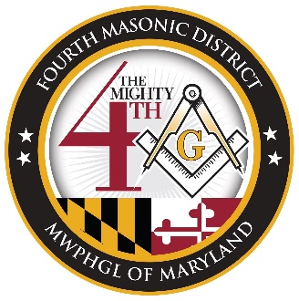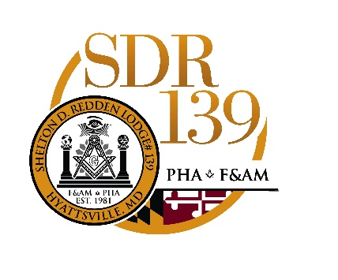

David D. Curtis Jr.
Worshipful Master
2115 Branch Ave S.E
Washington DC. 20020
david.crtsjr@gmail.com
202-422-7721

Regular Communication: 2nd Monday @ 7:30pm
Staff Meetings: 4th Monday @ 7:30pm

Meeting address: 6060 Sargent Road, Hyattsville, MD 20782
Mailing Address: PO Box 5177, Hyattsville, MD 20782
Website:sheltondredden139.com
Email: sheltondredden139@gmail.com
Facebook: https://www.facebook.com/sdr139/
Instagram: @sublime139 or https://www.instagram.com/sublime139/

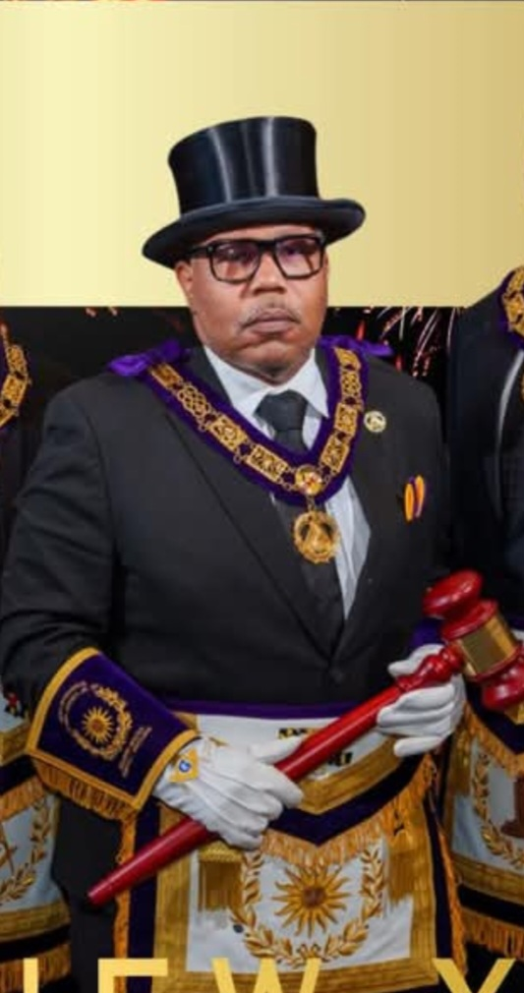

The Honorable

Kevin L Barney Jr.
Most Worshipful Grand Master

Most Worshipful Prince Hall Grand Lodge of Maryland

Grand Lodge Elected Officers

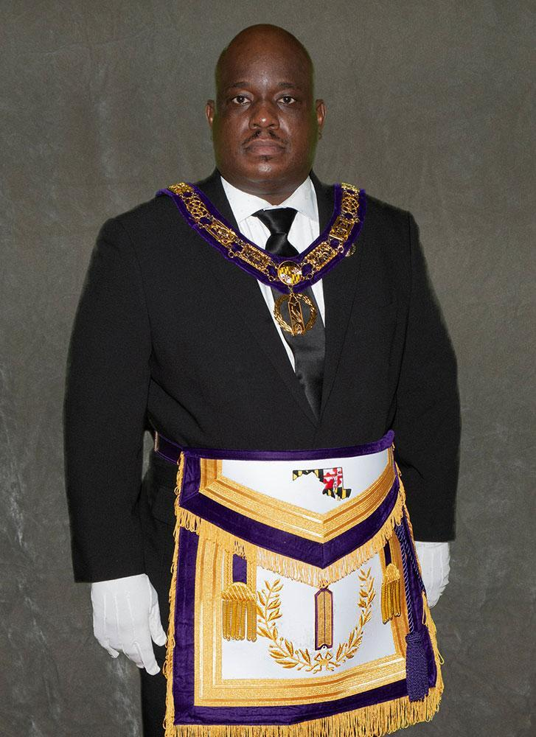 | 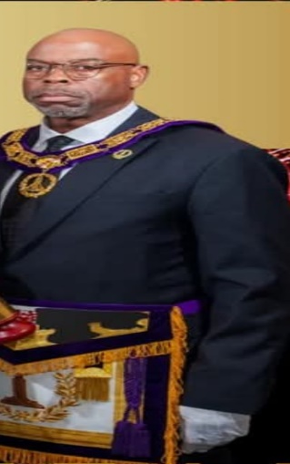 | 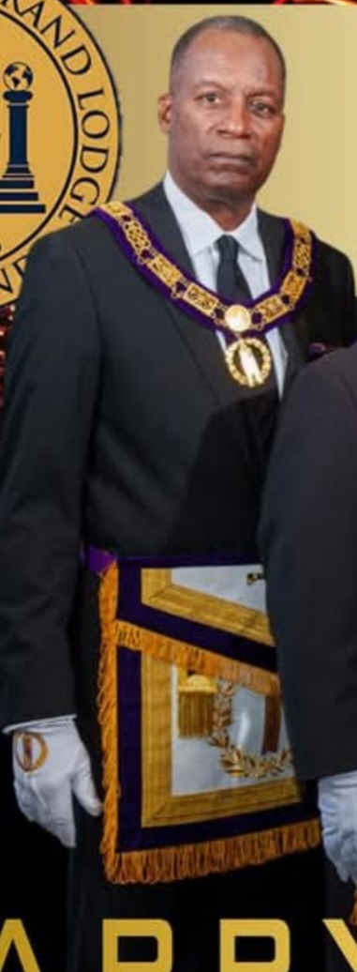
RW Randolph S. Smith Sr.  Deputy Grand Master | RW Otis Wilson  Senior Grand Warden | RW Michael Haynie  Junior Grand Warden

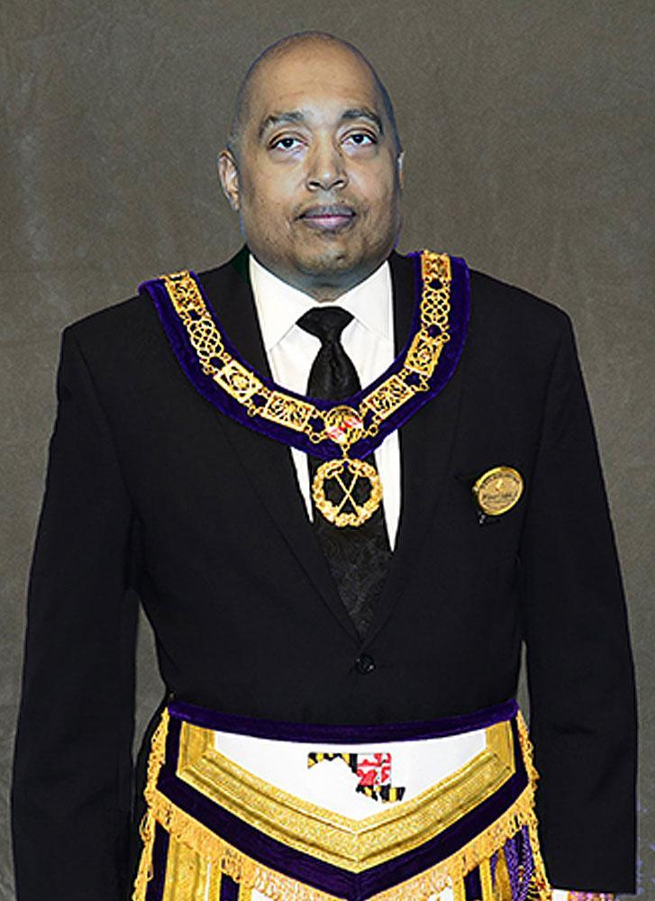 | 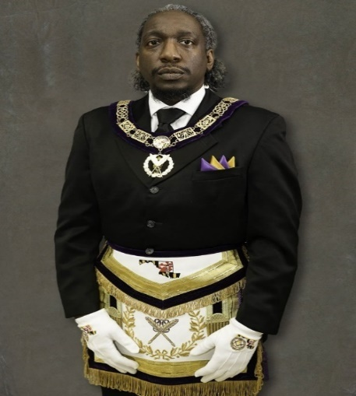

RW Rodney James
Grand Secretary

Table of Contents

MWPHGLMD Grand Master 2
MWPHGLMDStaff Info 3
Table Of Contents 4
MWPHGLMD Info 5
Statement Of Purpose 6
MWPHGLMD 4th Masonic District Staff/SDR#139 Officers 2024-2025 7
MWPHGLMD 4th Masonic District Lodges 8
Fourth (4th) Masonic District Degree Calendar 2024-2025 9
WM Acceptance Letter 10
Shelton D. Redden Lodge #139 Vision, Mission & Goals 11
Shelton D. Redden Lodge #139 Vision, Mission & Goals cont' 12
Prince Hall History 13
Prince Hall cont' 14
SDR #139’s Namesake MWPGME Shelton D. Redden 15
History of Shelton D. Redden Lodge #139 cont' 16
Shelton D. Redden Lodge #139 Past Masters 17
Shelton D. Redden Lodge #139 Past Masters cont' 18
Lodge Elected and Appointed Officers 2024-2025 19
Committee Assignments MY2024-2025 20
Committee Assignments MY2024–25 Cont’ 21 SDR #139 Widows & Orphans 22
SDR#139 Event & Administrative Calendar 2024-2025 23-28
Membership Birthday 29-30
Membership Roster 31-39

1307 Eutaw Place
Baltimore, MD, 21217
Phone: 410-669-4966
Fax: 410-462-4642
Email: Grand_Master@mwphglmd.org
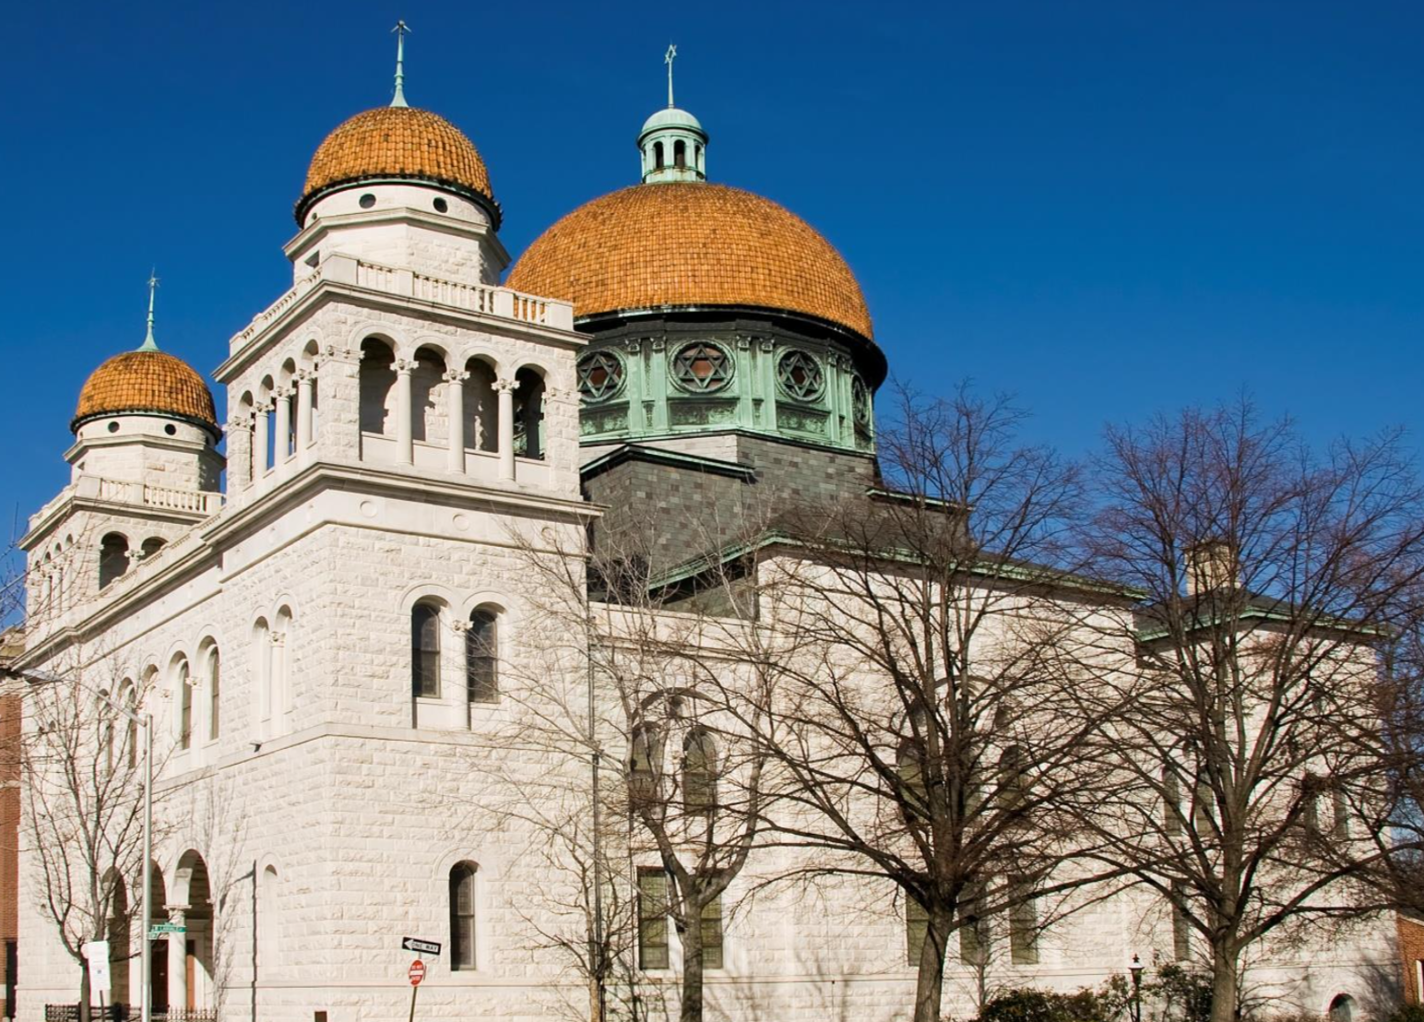
Website: http://www.mwphglmd.org

Statement Of Purpose
This Trestle Board is for the notification and edification of the brethren of Shelton D. Redden Lodge #139, the 4th Masonic District and the Prince Hall Family.
This Trestle Board should be used to publicly advertise and to promote the activities of the Lodge within the community in general and the Jurisdiction of Maryland.

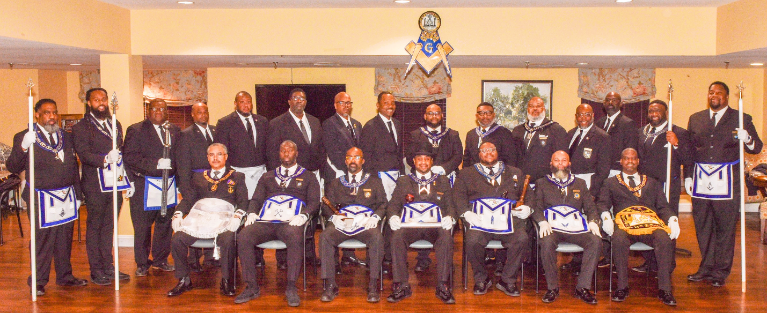
Shelton D. Redden Lodge #139 2024-2025 Officers, R.W.’s and P.M.’s

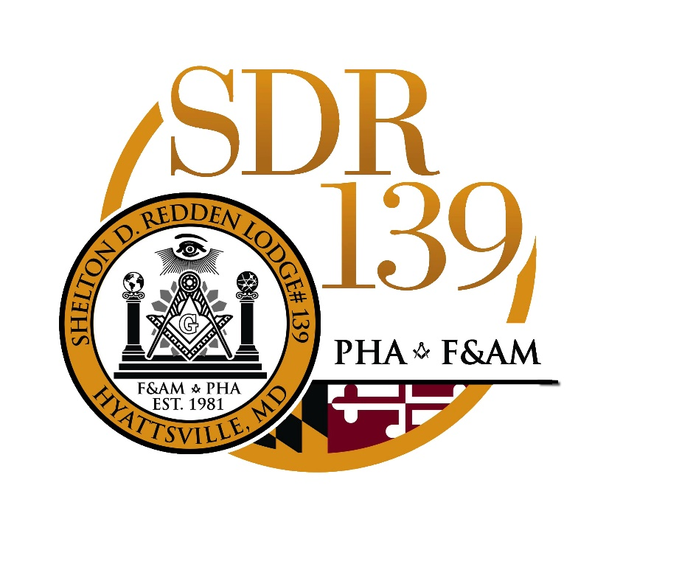

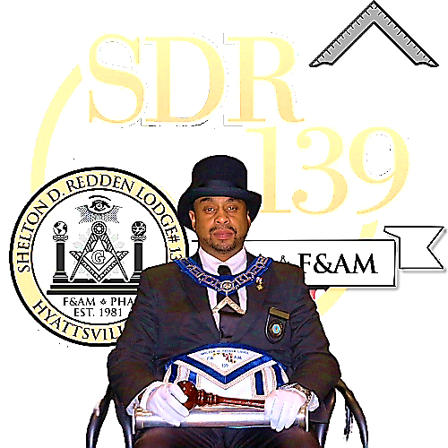

WM David D. Curtis Jr.
Of
Shelton D. Redden Lodge #139
4th Masonic District
Most Worshipful Prince Hall Grand Lodge of Maryland
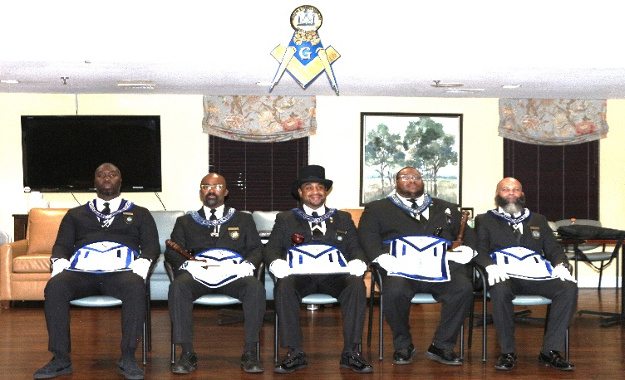
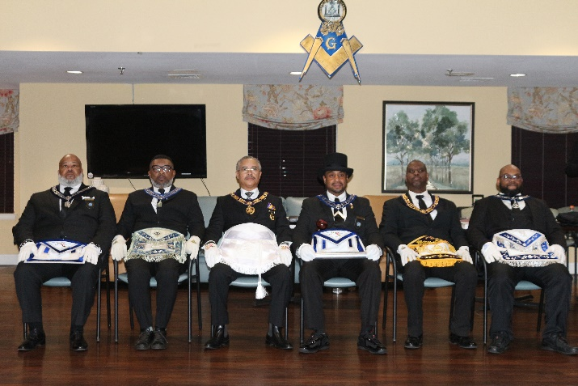
Shelton D. Redden Lodge #139
Principal Officers 2024-2025
(Left to right): Treasurer Jeremey Howard, Senior Warden Everett Martin, WM David Curtis, Junior Warden Rodney Crawley, Secretary Terence Davis

Shelton D. Redden Lodge #139 Past Grand Master, Right Worshipful, and Past Masters council
(Left to Right): Past Master Jerrell Latham, Past, Past Master Johnathan Gentry, Most Honorable Past Grand Master Dwayne Wright, WM David D. Curtis Jr., Right Worshipful Kevin Stephen, Right Worshipful Greg Davis

Grand Lodge Calendar

qSat Jan 18, 2025, MWPGM Gold Collar @12:00pm
qMon Jan 20th, 2025– MLK Day Parada in Baltimore MD
qWed Jan 22nd, 2025- –Deadline for Article Sub- 7:00 p.m. G.L. Website Newsletter mission The Light
qSun Feb 2nd, 2025, Bicentennial Church Service 3:00 p.m. Sharp Street Baptist GM Church, Baltimore, Maryland
qSat Feb 10th, 2025, Jurisdictional Town Hall Meeting 2:00 p.m. Masonic Temple GM
qSat Feb 15th, 2025- Black History Month 2:30 p.m. Coppin State Univ. GM – Rahab Day and Queen Coronation
qSat Mar 1st, 2025-– 1st Occasional Grand Lodge 9:30 a.m. Masonic Temple GM, Host: District Meet
qSat-Mar 8-10-2025 –Across Edmund Pettus 11:00 a.m. Selma, AL GM Bridge
qSat-Mar 29th, 2025–1st Degree Exemplification TBA Masonic Temple Grand Lecturer
qSat May 3rd, 2025–Town Hall Meeting 9:00 a.m. Virtual GM
qSat June 14-15th 2025–Juneteenth Celebration TBA Annapolis, MD GM [MWPHGL MD]
qSat June 21st, 2025–Occasional Grand Lodge 9:30 a.m. Masonic Temple GM, Host District Meeting
qSat June 20th 20225- Deadline for the Article Submission for the light
qSat June 21st, 2025–Occasional Grand Lodge 9:30 a.m. Masonic Temple GM, Host District Meeting
qSat June 22nd, 2025 - Annual St. John’s Day Service To be held in each District under auspices of each DDGM
qSat June 28th, 2025 - 2nd Degree Exemplification Grand Lecturer TBA for time and place.
qSat July 5th, 2025 - Jul 5 Crab Feast TBA Martin’s Crosswind GJW
qSat August 9th, 2025, Sat. Aug 9 District Deputy Grand 9:00 a.m. Masonic Temple GM Master’s Workshop
qSat August 30th, 2025, 3rd Degree Exemplification TBA Masonic Temple Grand Lecturer
qSat September 6th, 2025- Children’s Cookout TBA Time and place GJW
qSun September 7th, 2025- Prince Hall Day Ceremony 2:30 p.m. Samuel T. Daniels GJW/GL
qSat September 27th, 2025-3rd Occasional Grand Lodge 9:00 a.m. TBA GM, Host:
qSat October 25th, 2025- Football Game TBA Bowie State Univ. GL

MWPHGLMD 4th Masonic District Staff MY2022

District Deputy Grand Master
RW Duron Haynesworth Charles H Wesley Lodge #147
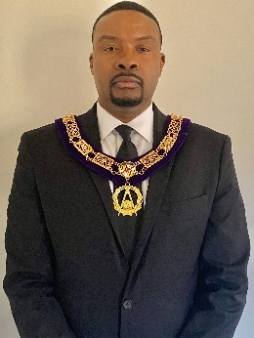
djaygill@aol.com
240-375-5346 (Cell)
Assistant District Deputy Grand Master
R.W. Keon Anthony Shelton D Redden Lodge #139

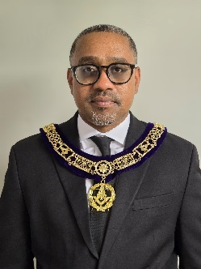
keonanthony@gmail.com
202-487-7193 (Cell)
Protocol Officer | 4th District Staff | Community Engagement
R.W. Bryon Simmons (CHW#147)  Bsimmons3147@icloud.com  410-371-8925 |  | R.W. Cordell B. Johnson  Cbjhonson021@gmail.com  301-343-5530

MWPHGLMD 4th Masonic District Lodges & Officers 2024-2025

Charles H Wesley Lodge #147
P.O. Box 848  Bowie, MD 20718 |  |  | 2nd, 4th Thursday @ 7:30pm
Office | Name | Phone |  | Email

WM | Anthony Hill | 443-699-0529 | Anthony.hill014@outlook.com
SW | Lawrence Mercer | 202-497-1010 | lawrencejmercer@gmail.com
JW | Jordan Beckford | 240-664-4663 | Jobec93@gmail.com
Secretary | Deron Pittman | 202-506-0171 | Deron.pittman@dgpenterprises.com
Treasurer | Ronald Taylor | 301-346-0346 | Rtaylor0256@verizon.net

Fairmont Lodge #92
5501 Addison Rd  Fairmont Heights, MD |  |  | 2nd, 4th Wednesday @ 7:30pm
Office | Name | Phone |  | Email
WM | Devon Peter | 202-506-0171 |  | devon.peter@gmail.com
SW | Darrius Williams | 240-408-0564 |  | Darrius19972@yahoo.com
JW | Robert Gass | 240-419-1434 |  | gassrob@gmail.com
Secretary | Ricardo Moore | 202-506-0171 |  | Ramoore927@gmail.com
Treasurer | Lonell C. Wilson | 240.350.5306 |  | lcw1906@aol.com

King Solomon Lodge #7
5501 Addison Rd  Fairmont Heights, MD |  |  | 2nd, 4th Friday @ 7:30pm
Office | Name | Phone |  | Email

WM | John O. Peace | 702--675-5673 | fordmastersautorepair.com
SW | Cedric Hammond | 202-369-5445 | Chamm891@gmail.com
JW | Dwayne Zachery | 202-257-5119 | Allpro23Z@yahoo.com
Secretary | Darnell Springfield | 240-475-0964 | darrellspringfield@hotmail.com
Treasurer | Hubert Turner | 240.472.6044 | mrheturner@yahoo.com

Fourth (4th) Masonic District Degree Calendar 2024 – 2025

Month | MWPHGLMD | KS#7 | FAIR#92 | SDR#139 | CHW#147
Nov
Dec
Jan
Feb |  |  |  | (1stDegree)  Monday February 10th 2025 7:30 PM
March
April
May |  |  |  | (2nd Degree)  Monday May 12th 2025 @7:30pm
June
July |  |  |  | (3rd Degree) Saturday July 27th @9:30am
August
Sept
Oct

Worshipful Master Acceptance Letter

Dear RWs, PMs and Brothers All,

First and foremost, I want to thank the Great Architect of The Universe for every blessing and lesson it took to get here on my masonic journey. Every Past Master who sat in the East before me has left me with something valuable in preparation to be the face of Shelton D. Redden lodge 139. To those before me, thank you. Of course, to all brothers, thank you for your vote of trust and this opportunity to lead.

I am deeply humbled and honored to have been selected as the Worshipful Master of our lodge. During this journey, I have learned so much from all of you and I pray that through your continued support, and guidance I will be able to bring more success to our lodge and strengthen our brotherhood.

This is a responsibility I do not take lightly, and I am fully committed to serving our craft to the best of my abilities. Together, we will continue to uphold the principles and values that our lodge stands for.

I look forward to the journey ahead and the opportunity to work alongside such dedicated and respected individuals. Your support and encouragement mean the world to me, and I am excited to lead our lodge with your guidance and partnership. Thank you once again for this incredible privilege.

Fraternally,

WM David D. Curtis Jr.
Shelton D. Redden Lodge #139
6060 Sargent rd.
Hyattsville MD.
(202)-422-7721
david.crtsjr@gmail.com

Vision

The vision of Shelton D. Redden Lodge No. 139 (SDR#139) is to continue to make good men better and mirror those efforts throughout our community.

Mission

The mission of SDR 139 is to harvest skill sets that men can use in both masonry in the real world, to propel themselves to be better husbands, fathers, employees, and upstanding citizens within their community.

MY 2024-2025 Goals

Our Goals for the Community – Include but aren’t limited to fostering relationships with community stakeholders and anchoring ourselves in Hyattsville as a premier volunteer organization.

Our Goals for the Youth – To build relationships through tutoring and mentor efforts and contributing to the K.O.P. program.

Our Goals for Ourselves – As masons our goals start with being upright men, even in the face of adversity. In an operative application, we will aim to be a timely lodge that is proficient in ritual and prioritizes our brother’s growth as they evolve as masons and men. As we work to become better men, we will strengthen our Lodge, Community and Grand lodge with our backbone of dedication, hard work, and outstanding effort.

Shelton D. Redden Lodge #139 seeks to strengthen the bonds of unity and friendship amongst the craft by working towards common goals with respect to community service, fundraisers, fellowship, Masonic education, and effective lodge stewardship. Our goals include:

Community Service
- Delivering food baskets to families in Hyattsville during Christmas and Thanksgiving seasons.
- Deliver donated school supplies to teachers at neighboring elementary schools.
- Re-establishing our connection with the City of Hyattsville and participating in: Annual Pancake Breakfast, Hyattsville Parade, Hyattsville National Night Out, and
Hyattsville Summer Jam Series

- Overseeing bingo night for Rolling crest residents every third Friday of the month.

Fundraisers
- Achieve minimal 75% Return on Investment
- Generating at least 10% increase in profit from fundraising efforts
- Initiate residual income mechanism(s)/sustainable business model.
- Establish annual gala for SDR Anniversary, Community Partner, Scholarship

Fellowship
- Conducting at least 4 fellowship events
- Increase attendance at meetings by 10%
- 100% officer-representation at GL Events (At least 1 officer at each GL event)
- 100% of officers visit each Lodge in the 4th Masonic district.
- Travel out of state to support a lodge from a different state.
- Conduct church visits
- Continue the Phamily Cookout with 4th District, Western York Rite and add an OES chapter as a partner.

Masonic Education
- Host at least one 1st, 2nd, and 3rd degree ceremony
- Provide a lecture discussion at each regular communication.
- Raising our own Master Masons
- Conduct quarterly education calls.
- Ritual training with the Black Book Club
- Conduct Lodge Retreat, State of the Lodge, and Close out Retreat
- Provide Trainings for Officers and lodge members.
- Masonic Voting (By Laws, and Elections)

Stewardship
- Meeting with Rolling crest Management at least quarterly
- Post weekly social media communications across all platforms.
- Provide a quarterly update of content to the lodge website.
- Adhere to all GL Administrative actions.
- Submit Lodge, District, and GL reports on time.
- Provide transparency into all financial and administrative actions of the lodge.
- Reinforce financial and administrative processes/ complete reports of activities.
- Re-establish the PM Council and meet quarterly to discuss future Leadership training for the Lodge.
- Come up different ideas to sell GL raffle tickets.

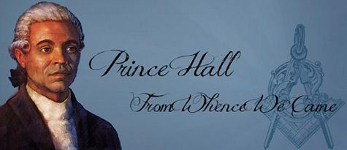
Prince Hall is recognized as the Father of Black Masonry in the United States. He made it possible for us to also be recognized and enjoy all privileges of Free and Accepted Masonry.
Many rumors of the birth of Prince Hall have arisen. Few records and papers have been found of him either in Barbados where it was rumored that he was born, but no record of birth, by church or state, has been found there, and none in Boston. All 11 countries of the day were searched and churches with baptismal records were examined without a find of the name of Prince Hall.
One widely circulated rumor state that Prince Hall was free born in the British West Indies. His father, Thomas Prince Hall, was an Englishman and his mother a free colored woman of French extraction. In 1765 he worked his passage on a ship to Boston, where he worked as a leather worker, a trade learned from his father. Eight years later he had acquired real estate and was qualified to vote. Religiously inclined, he later became a minister in the African Methodist Episcopal Church with a charge in Cambridge.” This account, paraphrased from the generally discredited Grimshaw book of 1903, is suspect in many areas.
Black Freemasonry began when Prince Hall and fourteen other free black men were initiated into Lodge No. 441, Irish Constitution, attached to the 38th Regiment of Foot, British Army Garrisoned at Castle William (now Fort Independence) Boston Harbor on March 6, 1775. The Master of the Lodge was Sergeant John Batt. Along with Prince Hall, the other newly made masons were Cyrus Johnson, Bueston Slinger, Prince Rees, John Canton, Peter Freeman, Benjamin Tiler, Duff Ruform, Thomas Santerson, Prince Rayden, Cato Speain, Boston Smith, Peter Best, Forten Howard and Richard Titley.
When the British Army left Boston in 1776, this Lodge, No 441, granted Prince Hall and his brethren authority to meet as African Lodge #1 (Under Dispensation), to go in procession on St. John’s Day, and as a Lodge to bury their dead; but they could not confer degrees nor perform any other Masonic “work”. For nine years these brethren, together with others who had received their degrees elsewhere, assembled and enjoyed their limited privileges as Masons. Thirty-three masons were listed on the rolls of African Lodge #1 on January 14th, 1779. Finally on March 2, 1784, Prince Hall petitioned the Grand Lodge of England, through a Worshipful Master of a subordinate Lodge in London (William Moody of Brotherly Love Lodge No. 55) for a warrant or charter.
The Warrant to African Lodge No. 459 of Boston is the most significant and highly prized document known to the Prince Hall Mason Fraternity. Through it our legitimacy is traced, and on it more than any other factor, our case rests. It was granted on September 29, 1784, delivered in Boston on April 29, 1787 by Captain James Scott, brother-in-law of John Hancock and master of the Neptune, under its authority African Lodge No. 459 was organized one week later, May 6, 1787.
Prince Hall was appointed a Provincial Grand Master in 1791 by H.R.H., the Prince of Wales. The question of extending Masonry arose when Absalom Jones of Philadelphia, Pennsylvania appeared in Boston. He was an ordained Episcopal priest and a mason who was interested in establishing a masonic lodge in Philadelphia. Under the authority of the charter of African Lodge #459, Prince Hall established African Lodge #459 of Philadelphia on March 22, 1797 and Hiram Lodge #3 in Providence, Rhode Island on June 25, 1797. African Lodge of Boston became the “Mother Lodge” of the Prince Hall Family. It was typical for new lodges to be established in this manner in those days. The African Grand Lodge was not organized until 1808 when representatives of African Lodge #459 of Boston, African Lodge #459 of Philadelphia and Hiram Lodge #3 of Providence met in New York City.
Upon Prince Hall’s death on December 4, 1807, Nero Prince became Master. When Nero Prince sailed to Russia in 1808, George Middleton succeeded him. After Middleton, Petrert Lew, Samuel H. Moody and then, John T. Hilton became Grand Master. In 1827, Hilton recommended a Declaration of Independence from the English Grand Lodge.
In 1869 a fire destroyed Massachusetts’ Grand Lodge headquarters and a number of its priceless records. The charter in its metal tube was in the Grand Lodge chest. The tube saved the charter from the flames, but the intense heat charred the paper. It was at this time that Grand Master S.T. Kendall crawled into the burning building and in peril of his life, saved the charter from complete destruction. Thus a Grand Master’s devotion and heroism further consecrated this parchment to us, and added a further detail to its already interesting history. The original Charter No. 459 has long since been made secure between heavy plate glass and is kept in a fire-proof vault in a downtown Boston bank.
Today, the Prince Hall fraternity is the largest predominantly African American Masonic body in North America. It has over 4,500 lodges worldwide, forming 45 independent jurisdictions with a membership of over 300,000 masons.

About SDR #139’s Namesake

MWPGME Shelton Dennis Redden

October 17, 1936 - February 21, 2015

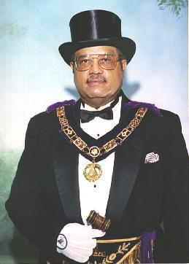
Most Worshipful Past Grand Master Emeritus (MWPGME) Shelton Dennis Redden was born in Cleveland, Ohio to the loving couple of Marian E. Jackson and John Redden. At a young age his parents relocated to Toledo, Ohio where he received his formal education. After graduating from Libby High School, GME Redden decided to enter the US Air Force where he remained for 28 years. He retired from the US Air Force as a Chief Master Sergeant, the highest enlisted grade achievable. During his Air Force career, he obtained his Associates of Arts degree in Information Services from the Community College of the Air Force. He received his Bachelor of Arts Degree in Digital Processing from Golden Gate University in 1976. During his Air Force career, GM Redden was assigned to Korea, Japan, Philippines, Thailand, England, and was involved in the TET offensive in Vietnam (1967-68). For his combat service in the TET offensive in Vietnam, he was awarded the Bronze Star for Valor. GME Redden was shown the light in Prince Hall Military Lodge #103 in Lancaster, California and was raised a Master Mason on May 16, 1970. He learned the beauty of Masonry under the watchful guidance and well-informed direction of the late Joseph A. Meekins, a revered Master Mason in Southern California. Continuing his ascension, GM Redden advanced to the 33rd degree in Kansas City, Missouri in October of 1977. He was elevated to active 33rd degree in October 1988 when the late Dr. I.H. Clayburn, the Sovereign Grand Commander at that time, appointed him Deputy for the Supreme Council, Orient and State of Maryland.
He was elected Grand Minister of State at the United Supreme Council, Ancient and Accepted Scottish Rite of Freemasonry, Prince Hall Affiliation, Southern Jurisdiction, USA in October of 1991. He served as the 1st Lt. Grand Commander. He currently serves as President of the Grand Masters Council for Prince Hall Masons. He had also served as the Worshipful Master of Donald E. Jones Lodge #121, as the DDGM of the 13th Masonic District in the United Kingdom, and as the Grand Junior Warden of the MWPHGL of Maryland and Jurisdiction. He was elected to the office of Junior Grand Warden in August of 1993 and to the office of Deputy Grand Master in August 1996. On August 10, 1998, he was elected to the most prestigious position in Prince Hall Masonry in Maryland, that of the Grand Master. He is a member and Past Master of King Solomon Lodge #7, Past Commander-in -Chief of James A. Mingo Consistory #334, and Past Potentate of MISR Temple #213, all of which are in the Jurisdiction of Maryland. In the spring of 1997 he was the recipient of the Gold Medal Achievement Award. MWPGME Emeritus Redden stepped down in December 2010, handing over the reins of leadership to MWPGM Melvin M. Thorpe. MWPGME Redden was called from labor to reward on February 21, 2015. He was married, had 5 children and 3 grandchildren.

History of Shelton D. Redden Lodge #139
The MW Samuel T. Daniels, Grand Master of the Most Worshipful Prince Hall Grand Lodge of Maryland and its Jurisdictions granted Shelton D. Redden Lodge #139 a charter in Oxfordshire, England on July 11, 1981. The initial principal officers of the fledgling lodge were LeRoy White as the Worshipful Master, Robert E. Burruss as the Senior Warden, and Robert M. Long as the Junior Warden.
Many members were shipped to other assignments or stations due to their military careers and the lodge was later disbanded. The charter was then sent back to the Grand Lodge. Nearly ten years later in 1992 Gerald Black, James Jones, and others formed the Hyattsville Study Club with the necessary number of Masons. Brother Black made a request for the charter to MW Samuel T. Daniels, Grand Master. The charter was granted Dec. 11, 1992, at the Second Constituent Lodge Workshop meeting and reissued with Gerald Black as Worshipful Master, James Jones as Senior Warden, and Ronald Raiford as Junior Warden. They were then installed as the Lodge’s primary officers and the charter was activated on January 1, 1993.
Meetings were held at Bright Light Baptist Church in Takoma Park, MD. The fledgling lodge initially met in one of the conference rooms until church restructuring forced them to meet in a storage room. Further discomfort was added when washers and dryers were installed in the small room. Due to space limitations, lack of security and the increasing discontent of certain members of the church at sharing that storage area with a lodge, the decision was made to move to Fairmount Lodge #92 for meetings.
During the administration of WM Charles B. Clark, RW Walter W. Brown was appointed as the District Deputy Grand Master for the Fourth Masonic District of Maryland. RW Brown wanted the lodge to move back into the Hyattsville area. Therefore, the lodge moved again and began to meet at New Dawn Baptist Church in West Hyattsville, MD. Under the leadership of WM Northern, the Lodge was able to move to a more compatible location, Rolling crest Commons, also in West Hyattsville and it is there that they currently hold their meetings.
The lodge listed many successes among their early accomplishments. A few of these projects were the creation of their own staff and columns, the purchase of new collars, the replacement of borrowed jewel adornments, the acquisition of administrative supplies, and the establishment of a purchase plan for covers at the principal stations. Shelton D. Redden Lodge #139 has grown and matured significantly since then and despite the early trying times it has faced since its humble beginnings, the lodge has had several successful classes and has raised over fifty-five brothers. Shelton D. Redden Lodge #139 may remain small in numbers but the charity from our hearts is large and is displayed through the charitable work done throughout our community.
Shelton D. Redden Lodge #139 Past Masters

1980s
Jul 1981 – Jun 1982 | Past Master Leroy White
Jul 1982 – Jun 1983 | Past Master Robert M. Long
Jul 1983 – Jun 1984 | Past Master John E. McClendon
Jul 1984 – Jun 1985 | Past Master Alton B. Gaither
Jul 1985 – Jun 1987 | Past Master Frederick D. Watson
Jul 1987 – Jun 1988 | Past Master Lonnie A. Gallman
Jul 1988 – Jun 1989 | Past Master Richard J. Perkins, II
Jul 1989 – Jun 1990 | Past Master Douglas A. Brown
1990s
Jul 1990 – Dec 1992 | Period of Inactivity
Jan 1993 – Jun 1993 | Past Master Gerald Black
Jul 1993 – Jun 1994 | Past Master James C. Jones
Jul 1994 – Jun 1995 | Past Master Ronald M. Raiford
Jul 1995 – Jun 1996 | Past Master Charles B. Clark, III
Jul 1996 – Jun 1997 | Past Master Randy Truesdale
Jul 1997 – Jun 1998 | Past Master Percy O. Williams
Jul 1998 – Jun 1999 | Past Master Walter H. Hawkins
Jul 1999 – Jun 2000 | Past Master Julius C. Jefferson

Shelton D. Redden Lodge #139 Past Masters (Continued)

2000s
Jul 2000 – Jun 2001 | Past Master William A. Northern
Jul 2001 – Jun 2002 | Past Master William A. Northern
Jul 2002 – Jun 2003 | Past Master Dwayne E. Wright, Sr.
Jul 2003 – Jun 2004 | Past Master Dwayne E. Wright, Sr.
Jul 2004 – Jun 2005 | Past Master Jamie L. Dawson
Jul 2005 -- Jun 2006 | Past Master Danny W. Pimienta
Jul 2006 -- Jun 2007 | Past Master Ralph A. Rogers
Jul 2007 – Jun 2008 | Past Master Rudolph D. Smith, Jr.
Jul 2008 – Jun 2009 | Past Master Brent Hughes
Jul 2009 – Jun 2010 | Past Master J. Brooke Cawley
2010s
2010 GM Honoree | Past Master Armstead Williams
Jul 2010 – Jun 2011 | Past Master Kevin Stephen
Jul 2011 – Oct 2012 | Past Master Jonathan Gentry
Nov 2012 – Oct 2013 | Past Master Kevin Stephen
Nov 2013 – Oct 2014 | Past Master Chad Malone
Nov 2014 – Oct 2015 | Past Master Chad Malone
Nov 2015 – Oct 2016 | Past Master Anthony Summers
Nov 2016 – Oct 2017 | Past Master Terence J. Clegg, Sr.
Nov 2017 – Oct 2018 | Past Master Michael Davis
Nov 2018 – Oct 2019 | Past Master Keon Anthony
Nov 2019 – Oct 2020 | Past Master Lloyd Shanklin
Nov 2020- Oct 2021 | Past Master Lloyd Shanklin
Nov 2021- Oct 2022 | Past Master Greg Davis
Nov 2022-Oct 2023 | Past Master Gerard Weaver
Nov 2023-Oct 2025 | Past Master David D. Curtis Jr.

Lodge Elected Officers for MY 2024- 2025

Office | Name | Cell | Email
WM | David Curtis | 202-422-721 | davidcrtsjr@gmail.com
SW | Everett Martin | 917-513-6015 | Everettnartin06@gmail.com
JW | Rodney Crawley | 240-393-2462 | Crawley53@gmail.com
Secretary | Terence Davis | 301-892-1124 | Terence@Qremod.com
Treasurer | Jeremy Howard | 202-460-7965 | Jeremyhoward41281@yahoo.com

Lodge Appointed Officers for MY 2024 - 2025

Office | Name | Cell | Email
SD | Bryan Walls | 301-828-0033 | crusier0148@hotmail.com
JD | Keithen May | 240-605-2213 | Keithen.may@icloud.com
SS | Marques Julius | 301-213-7404 | Marques392@gmail.com
JS | Jay Sammy | 860-729-1077 | Christopher.bscmba@gmail.com
Chaplain | Jerell Latham | 301-974-7869 | Jayman1264@yahoo.com
Marshall | Marcus McCauley | 202-704-1077 | macm276@gmail.com
Tyler | Warren Brown | 202-733-7690 | warrenbrown3@aol.com
Asst. Treas | Keith Taylor | 301-742-9948 | letaff@comcast.net
Rec. Sec | Warren Hayes | 240-508-7449 | warhayes@hotmail.com

Shelton D. Redden #139 Committees 2024-2025

Masonic Education  Chair-SW Everett Martin  Co-Chair-WM David D. Curtis Jr. | PM Council  Chair PM Mike Davis  Chair PM Brooke Cawley  Co-Chair PM Greg Davis  Co-Chair PM Keon Anthony
Widows And Orphans  Chair: Bro Chaplain Jerell Latham | Amnesty  Chair SW Everett Martin  Co- Chair PM Greg Davis  Bro. Secretary Terence Davis
Governance (incl. By-Laws)  Chair- RW Greg Davis  WM David Curtis  RW- Ronald Raiford  Sec. Terence Davis | MLK Day Of Service  Chair- WM David D. Curtis Jr.  Chair Bro SW Everett Martin  Co-Chair Bro. JW Rodney Crawley
Investigation (membership intake)  Chair-SD Bryan Walls  Co-Chair-PM Keon Anthony  Co-Chair-WM David Curtis  Co-Chair-SW Evertte Martin | Hyattsville Comm Svc Liaison  Bro. PM Kevin Stephen  WM David Curtis  PM Mike Davis  PM Keon Anthony
Grand Lodge Raffle  Chair Bro SW Everett Martin  Co-Chair Bro Rodney Crawley  Co-Chair WM David Curtis  *All Officers Required to Assist | Basket of Cheer/Valentines Day Basket/Awards Banquet Basket  Chair- SW. Everett Martin  Co-Chair- Bro. Curtis Wilson  Co-Chair WM David Curtis  JW Rodney Cawley  JS Jay Sammy
Visitation and Relief  Chair-WM David Curtis  Co-Chair- SW. Everett Martin  Co-Chair- JW Rodney Crawley | Fundraising Committee  Chair- Past Master Mike Davis  Co-Chair- Senior Warden Everett Martin  Co-Chair: WM David Curtis  Junior Warden Rodney Crawley  Treasurer- Jermy Howard  Secretary- Terence Davis
CHIPS  Co-Chair RW Kevin Stephen  Chair WM David Curtis  Senior Warden- Evertt Martin  Junior Warden- Rodney Crawley  Marshall- Marcus McCauley | SDR#139 Scholarship Committee  Chair-Right Worshipful Jammie Dawson  Co-Chair-Right Worshipful Kevin Stephen  Co-Chair- WM David D. Curtis Jr.  Treasurer- Jeremy Howard  Secretary- Terence Davis
Black and White Soiree  Chair- Treasurer Jeremy Howard  Co-Chair WM David Curtis  Junior Warden- Rodney Crawley | Thanksgiving Basket giveaway  Chair Bro Allen Davis  Co-Chair Right Worshipful- Ronald Raiford  Co-Chair- Assistant Secretary -Keith Taylor
Dallas Vs. Commanders Rolling Crest (Tailgate)  Chair- JW Rodney Crawley  Co-Chair – Treasurer Jeremy Howard  Co-Chair-Senior Stewart Marques Julius  Marshall- Marcus McCauley  Junior Stewart – Jay Sammy | PHAmily and Friends Day Cookout  Chair: JW Rodney Crawley  Co-Chair: Senior Stewart Marques Julius  Co-Chair: Junior S Jay Sammy  Marshall-Marcus McCauley  Secretary-Terence Davis  Treasurer- Jeremy Howard
Brotherhood Calls  Chair-Junior Warden- Rodney Crawley  Senior Stewart- Marquis Julius  Junior Stewart- Jay Sammy  Marshall: Marcus McCauley  Chaplin: Jerrell Latham  Secretary- Terence Davis | SDR Traveling Committee.  Chair: Senior Warden Everette Martin  Co-Chair: WM David Curtis  Senior Deacon- Bryan Walls  Junior Warden- Rodney Crawley  Past Master- Mike Davis
IT/Web Development  Chair Asst Sec- Bro Keith Taylor  Co-Chair- Junior Warden Rodney Crawley  WM David D Curtis Jr.  Senior Stewart- Marquis Julius  Juior Stewart – Jay Sammy | Social Media  Bro Senior Stewart Marquese Julius  Bro. Senior Warden Everett Martin  Asst Sec. Keith Taylor  JS- Jay Sammy
Hookie Committee  Chair- Junior Stewart- Jay Sammy  Co-Chair: Senior Warden- Everett Martin  Co-Chair WM David Curtis  Junior Deacon Keithen May  Past Master- Mike Davis  Junior Warden- Rodney Crawley  Senior Stewart- Marques Julius | Bingo Chair Senior Deacon. Brian Walls  CO-Chair- Tyler Warren Brown
SDR#139 Awards ceremony/Scholarship Event  Chair Junior Stewart Marques Julius  Co-Chair- WM David Curtis  Senior Warden- Everett Martin | SDR Christmas Potluck  Chair: Junior Warden Rodney Crawley  Co-Chair- Senior Stewart Marques Julius  Co-Chair- Junior Stewart- Jay Sammy  Marshall Marcus McCauley  Senior Stewart- Marques Julius  Secretary- Terence Davis
Preakness  Chair- SW Everett Martin  Co-Chair JW Rodney Crawley  Co-Chair JW Rodney Cawley  Co-Chair SD Brian Walls | Fantasy Football  Chair- Junior Warden Rodney Crawley  Co-Chair- RW Terence Clegg  Co-Chair -David Curtis
Rolling Crest Pancake Breakfast  Chair- WM David Curtis  Co-Chair Junior Warden Rodney Cawley  Senior Warden- Everett Martin  Senior Stewart- Marques Julius  Junior Stewart- Jay Sammy  Secretary- Terence Davis  Treasurer- Jeremy Howard | SDR Bowling Committee  Chair WM David Curtis  Co-Chair Senior Warden- Everett Martin  Junior Warden- Rodney Crawley  Secretary- Terence Davis  Treasure- Jeremy Howard

SHELTON D. REDDEN LODGE NO. 139 WIDOWS&Orphans

Daughter Of Brandon Crawford
(Info Needed)

Mrs. Margaret Smith
(PM Rudy Smith)
903 Lowander Lane
Silver Spring, MD 20901
301-439-7534

Mrs. Andrea Williams
(PM Percy Williams)
8202 Bathgate Court
Clinton, MD 20735
240-475-0155

“Learn to do good; seek justice, reprove the ruthless, defend the orphan, plead for the widow”. –Isaiah 1:

SDR 139 2024-25 Events & Administrative

Month | Event | Dates | POCs/Notes
November
Grand Lodge | Testimonial Ball MWPHGLMD | Saturday Nov 2nd  7:30 | WM David Curtis  SW Everett Martin  JW Rodney Cawley  Sec. Terence Davis  Tres. Jeremy Howard.
Interest Meeting/Community service project | Interest Meeting | Saturday Nov 23rd at 10:00am | Bro. SD Brian Walls  Bro. JD Keithen May  Stewards Refreshment  Double Check for Warden Agenda Points  LOC Reminder
Community Event | Thanksgiving Basket Giveaway | Saturday Nov 23rd 9:00 am | Bro. Allen Davis  Ridge Crest Principle for donation list.  Refreshments for Bros.  SDR Sign tables
Community event | Bingo Night | 3rd Friday  Nov 17th, 7:30pm | @ Rolling crest Community center  Bro. SD Bryan Walls
Community Event | Thanksgiving Dinner with the Residents of Rolling Crest | Sunday Nov 24th or Monday Nov 25th time TBD | Rolling crest Community Center
 | Staff Meeting/In-Person Mandatory for | Monday Nov 25th 7:30 pm Zoom Meeting | Send Zoom Link/Set GroupMe Reminder, Calendar Invites/Email etc.  Prepare a virtual copy of interest meeting material.
December
Grad lodge  Event | 175th Annual Grand Lodge Session | Dec 4th-Dec 7th  2024 | Bro. Secretary has secure Air B&B  Refreshments/Bro. JW  Hospitality Suite/Fundraiser?
Community Event | Interest Meeting (New Candidates) @ Fairmont or Rolling crest | Saturday 12/14/24  5:00pm | Bro. JW  Zoom Link distributed across all channels of communication.
Fundraiser Event | Baltimore VS. Miami Game  Fundraiser | Sunday 12/28/24 | WM David Curtis
Lodge Visit | John F Cook Lodge #10  DC Lodge Visit | Tuesday 12/12/24 7:00pm | WM David Curtis
Community Event | Bingo Night | Friday 12/20/24  7:30 PM | Bro. SD Bryan Walls  Bro. JD Rodney Crawley  Bro. Marshall Marcus McCauley
Lodge Meeting | Regular Communication | Monday 12/9/24, 7:30pm | Bro. JW/Stewards Refreshments  LOC Reminder
Lodge Event | SDR 139 PHAmily Holiday Potluck Party @ Fairmont or Rolling Crest | 12/14/24 5:00pm | Bro SW Everett Martin  Bro. SD Bryan Walls  Bro. SS Marques Julies  Bro. Assist Tres D’Andre Wilson  Possibly at Rolling Crest, Metropolitan Baptist Church, or Fairmont Lodge Basket of Cheer Raffle Bro. SW. Everett Martin
Fundraiser Event | SDR Reggae Christmas Party | 8:00pm – 1:00am @5 Sisters Bar & Lounge | Chair- SW Everett Martin  Co-Chair-
January
Community Event | Dallas Cowboys Vs. Washington Commanders Tailgate Party @ Rolling Crest | Sunday 1/5/25  TBD | Check with the rolling crest to make sure that we are on the Calendar for this day.
Lodge Meeting | Regular Communication | Monday 1/13/25 | Check in with the Wardens during the Monday Morning meeting.
Community Service | Martin Luther King Day Parade in Washington DC with John F. Cook Lodge #10 | Saturday 1/18/25  9:30 AM | See how many Officers would be willing to do the parade.
Degree Work | 1st Degree Practice | Wednesday 1/8/25  @7:30pm | Practice will be held at Rolling Crest @ 7:30pm
Degree Work | 1st Degree Practice | Week Of 1/15/25 | Bro. JW  Invite GL out to ensuing practice, to approve
Degree Work | 1st Degree Practice | Wednesday 1/22/25  @ 7:30pm | Practice will be held at Rolling Crest See JW for Details
 | Staff Meeting | Wednesday 1/27/25  Virtual Meeting | Vote on New petitions.
Grand Lodge | LOI Wardens school of Instruction | 1/11/25 | WM. David Curtis will be the Chair of this committee
February
Degree work | First Degree Practice | 2/5/25 | Practice will be held at Rolling Crest Senior Home.
Degree Work | Final 1st Degree Practice | 2/5/25 | Practice will be at Rolling Crest Senior Home
TBD | LOI Warden school of instruction | 2/8/25 | Check with Bro. Terence, .Bro. Sammy, Bro. Jeremy to see how things are going. Southern Region.
Lodge Meeting | Regular Communication/1st Degree | Monday  2/10/25 @ 7:30pm | Check with Bro SW. Everett Martin to make sure that he is ready for Degree work. Reminder email to the craft. Reminder to the 4th District.
Fundraiser | SDR 139 V-Day Basket of Cheer Giveaway | 2/13/25 | *Valentines Day Basket of Cheer Bro. SW. Everett Martin
Grand Lodge | Q1MY22 Audit Due | 2/15/25 | Bro. SW Everette/Audit Committee]
Community Event | Bingo | 2/21/25 | Bro SD Bryan Walls  Bro. Tylor Warren Brown
Gran lodge | Black History Month Celebration | Sun Feb 18, 2:30pm-5:30pm | TBD
 | Staff meeting | Monday 2/24/25@7:30pm | Zoom Link will be provided.
March
Grand  Lodge | 1st Constituent Grand Lodge Workshop | TBD | TBD
Southern Region | LOI Warden school of instruction | Sunday 3/09/25 | TBD
Brother hood Visit | PM Summer’s Birthday | Sunday 3/10/25 | Location TBA
Lodge Meeting | Regular Communication | Monday3/11/25 | Double Check with Wardens for agenda items.  Bro JW check in with Stewards regarding refreshment.
Community Event | Bingo Night | Friday  3/15/25, 7:30pm | Bro SD Bryan Walls  Bro. Tylor Warren Brown
Fellowship | SDR 139 Fellowship | Monday 3/17/25  (after bingo) | St Patty’s Green Day with the Bruh’s  TBD
 | Staff Meeting | 3/25/25 | Virtual meeting. Speak with Keith about the link for the meeting.
April
Degree Work | (1st) Second Degree Practice | Thursday 4/3/25 | Rolling Crest Bro. S.W. Everett Martin
 | Regular Communication @ Rolling Crest | Monday 4/14/25  @7:30pm | Check with Wardens Monday Morning.
Degree Work | 1st Second Degree Practice | Saturday 4/10/25 | Check with Bro. SW Everett Martin
L.O.I. | LOI Warden School of Instruction | Week of 4/13/25 | Southern Region TBD location
Degree Work | 2nd Degree Practice | 4/17/25 @7:30pm | Mt. Hermon  Check with SW to see if anything is needed and email all brothers.
Community Event | Bingo | Friday April 18th @7:30pm | Bro. SD. Bryan Walls  Bro. J.D. Rodney Crawley  Bro. Marshall Marcus McCauley
Community Event | Hyattsville Pancake Breakfast  or for Rolling Crest Senior Home | April 20th  8:00 am-10 am | J.W. Rodney Cawley  SS D’Andre Wilson  JS Marques Juilus  Magruder Park  Hyattsville, MD
Lodge Meeting | Staff Meeting/ State of the Lodge | Monday 4/28/25  @7:30pm | WM David Curtis Reminder Past Masters  Bro. SW, Reminder to Officers  Bro. JW. Remind the Craft  Bro. Sec. Terence Davis
Community Event | Hyattsville Day Parade | TBD | Hyattsville Middle School  6001 42nd Ave,  Hyattsville, MD 20781
Fundraiser Event | SDR#139  Bowling With Friends | Saturday 4/26/25  @3:00pm to 5:00pm | AMF Bowling Temple Hills MD.  WM David Curtis  JD Rodney Crawley  Treasurer Jeremy Howard
Grand Lodge | Mid-year Returns Q2 | Apr 30 | Due to District by May 15th
May
Degree Work | 2nd Degree Practice | Thursday 5/1/25  @7:30pm | Check with Bro. S.W. Everett Martin
Fellowship | SDR 139 Cinco De Mayo Fellowship | Monday 5/5/24 | Location TBD  Cigar Bar?  FOP?  Brother’s house?
Degree Work | FInal 2nd Degree Practice | Thursday 5/8/24  7:30pm | Double Check with Wardens for agenda items.  Bro JW check in with Stewards regarding refreshment.
Lodge Meeting | Regular Communication/2nd Degree | Week of 5/12/25 @7:30pm | Check with Wardens for
 | Final Second-Degree Practice | Week of 5/15/25  7:30pm | Bro. SW Everett Martin
Community Event | Bingo Night | Friday 5/16/25 @7:30pm | Bro. SD. Bryan Walls  Bro. J.D. Rodney Crawley  Bro. Marshall Marcus McCauley
Fundraiser Event | Preakness | Friday & Saturday  5/16/24-5/17/25  6:00am- 7:00pm | Pimlico Raceway  Bro. SW will have already promoted this event.  Coolers/ice with water and snacks for bros is negotiable this year. Request that all SDR 139 brothers work the same post.
Lodge Event | Second Degree Ceremony  (Replaces staff meeting) If needed. | 5/22/25  @7:30pm | Mt. Hermon  Bro. SW Invite/Remind District the week prior and days prior. June Communication= backup date
Grand Lodge | Q2MY21 Audit Due | May 30 | Due to Grand Inspector
June
Grand  Lodge | 2nd Constituent Grand Lodge Workshop | TBD | TBD
Community Event | Hyattsville Summer Jam Series | TBD | Recruitment, CHIPS
 | 3rd Degree Practice | Thursday 6/5/25  @7:30pm | Rolling Crest  7:30pm  WM David Curtis  Make sure that all parts are filled, and that you remind everyone to have their parts and come to practice. Reach out to PM’s to do certain parts of the 2nd section of the degree.
Lodge Meeting | Regular Communication | Monday 6/9/25  7:30pm | Double Check with Wardens for agenda items.  Bro JW check in with Stewards regarding refreshment.
 | 3rd degree Practice | Thurs 6/12/25 7:30pm | WM David Curtis
Community event | Bingo Night | Fridays  6/20/25  @7:30pm | @ Rolling Crest  Bro.SD. Bryan Walls  Bro. JD Rodney Cawley  Bro. Marshall Marcus McCauley
Grand Lodge | LOI Warden School of instructions | 6/13/25  10:00am | JW Everett Martin  JD. Rodney Crawley  Sec. Terence Davis
Grand Lodge | Annual St. John's Day Service | TBD | TBD
 | 3rd Degree Practice | Thurs 6/19/25  7:30pm | Rolling Crest  WM David Curtis
 | Staff Meeting (virtual) | Mondays 6/24/25 7:30pm | Bro. Assistant Secretary Distribute zoom link accordingly. Set reminders in GroupMe.
Fundraiser | Hookie Fundraising Event | 6/13/25 @12:00pm-8:00pm | Bro. JS Jay Sammy
Fundraiser | Wine Tour | TBA | Bro. SW Marting will provide further details for this event.
Community Service | 5k Walk for Prostate cancer | TBA | Bro. JW. Crawley Will provide further details for event.
July
Lodge Meeting | Regular Communication | Monday 7/14/25  @7:30pm | Double Check with Wardens for agenda items.  Bro JW check in with Stewards regarding refreshment.
Community Event | Begin Back to school supply drive | Mon 7/14/25 | Chair: PM Mike Davis  Co-Chair- Keith Taylor  Co-Chair JW Everett Martin
 | 3rd Degree Practice | 7/10/25  7:30pm | Rolling Crest  WM David Curtis  Final Dress Rehearsal check off to do the degree.
Community Event | Bingo | Friday 7/18/25  @7:30pm | Bro. SD. Bryan Walls  Bro. Tylor Warren Brown  Bro. Marshall Marcus McCauley  Rolling Crest
 | Final 3rd Degree Practice | Week of 7/17/25  7:30pm | Fairmont Lodge #92  WM David Curtis
 | Staff Meeting/Virtual | 7/28/25  7:30pm | Rolling Crest  WM David Curtis  SW Everett Martin  JW Rodney Crawley
 | 3rd Degree Ceremony Saturday July 26th | Saturday 7/26/25  9”30am | Location is TBD. Will be locked down before July
Fundraiser | SDR#139 Black and White Soiree Party Fundraising event | Saturday 7/26/25  Time: TBD | 5 Sister bar and Lounge
 | Q3MY21 Audit Due | July 31st, 2025 | Due 15 days after end of Quarter
August
Community Event | Hyattsville National Night Out | 8/5/25 @ 6:00pm | Recruitment, CHIP
 | Regular Communication | Monday 8/11/25 | Double Check with Wardens for agenda items.  Bro JW check in with Stewards regarding refreshment.
Community Service Event | Bingo | 8/15/25 | Rolling Crest Commons
Community Event | Family and Friends Cookout | Saturday 8/17/25 | Location: Old Magruder Park  Bro. SW Everett Martin  JW Rodney Crawley  SS. D’Andre Wilson  JS Marques Julius
 | Staff Meeting | 8/28/25 @7:30pm | Distribute Zoom Link Accordingly
Fundraiser | Fantasy Football League Draft | 8/28/25 | Chair- Bro. JD Rodney Cawley  Co-Chair- WM David Curtis
Grand lodge | Q3MY21 Audit Due | August 15th, | Due to the District 4th Staff
September
Grand Lodge | Prince Hall Children's Cookout | Saturday 9/6/25 | TBA
Grand Lodge | WSOI Graduation | TBD | TBA
Grand Lodge Event | Prince Hall Day Ceremony | Sunday 9/8/25 2:30pm | Grand Lodge
 | Regular Communication | Monday 9/8/25 7:30pm | Double Check with Wardens for agenda items.  Bro JW check in with Stewards regarding refreshment.
Community Event | Bingo Night | Fridays 9/19/25 7:30pm | @ Rolling crest Commons  Bro. Bryan Walls  Bro. Tylor Warren Hayes  Bro. Marshall Marcus McCauley
Staff Retreat | Staff Meeting/ In-Person | Monday 9/22/25  7:30pm | Metropolitan Baptist Church  Final Meeting for the Masonic Year. Close out/Discussions of New Administration
Lodge Event | SDR#139 Awards Banquet | Friday 9/27/24  7:30pm  or Saturday 9/28/24 6:00pm | JS Marques Julius  WM David Curtis  SW Emerson Bretous
October
 | EOY Retreat | TBD | Location TBD
Lodge Meeting | Regular Communication  Elections | Monday 10/13/25  @7:30pm | Double Check with Wardens for agenda items.  Bro JW check in with Stewards regarding refreshment.
Community Event | Bingo Night | 10/18/25 @7:30pm | Rolling crest Community Center.  Bro.SD Bryan Walls  Bro. Marshall Marcus McCauley  Bro. JD Rodney Cawley
Fellowship Event | SDR 139 Class Reunion Fellowship | Friday 10/17/25  7:00pm | Franklins or TBD  WM David D. Curtis Jr.
 | Staff Meeting | Monday 10/27/25 | @ Rolling crest Commons
Community Service | Trunk of Treat Halloween Event for the community | Friday 10/31/25 @5:00pm | Location will be provided from City of Hyattsville where our location will be
GL | End of year Returns | Oct 31 | 4th District Staff

Membership Birthday

January | Date |  | February | Date |  | March | Date
Dana Bailey | 1/1/1982 |  | Keith Anderson | 2/3/1956 |  | John Mason | 3/6/1961
Jedidayah Merriweather | 1/2/1987 |  | Shelton Sloan | 2/6/1978 |  | Derrick Whitted | 3/9/1970
Nico Calhoun | 1/6/1993 |  | Brooke Cawley | 2/15/1973 |  | Chris Harrison | 3/10/1988
Fritz Cenal | 1/12/1985 |  | Ivan Dawson | 2/15/1976 |  | Anthony Summer | 3/11/1967
Jay Walker | 1/24/1972 |  | Marshaun Walker | 2/15/1990 |  | Dwayne Wright | 3/13/1966
Armstead Williams | 1/30/1929 |  | Marques Julius | 2/16/1983 |  | De'Andre Moore | 3/18/1972
Ralph Edwards | 1/31/1968 |  | Allen Davis | 2/16/1966 |  | Mark Odom | 3/25/1955
 |  |  | Jamal Wood | 2/17/1987 |  | Kevin Stephen | 3/31/1973
 |  |  | Senghor Bey | 2/19/1977 |  | Keith Taylor | 3/7/1966

April | Date |  | May | Date |  | June | Date
Stephan Morina | 4/1/1971 |  | Alan Blanc | 5/1/1970 |  | Cam Fitzpatrick | 6/10/1985
Norman Lowe | 4/2/1970 |  | Brandon Manley | 5/3/1982 |  | Will Roots | 6/16/1984
Harold Thomas | 4/8/1985 |  | Alex Harris | 5/6/1980 |  | Gerard Weaver | 6/19/1985
Greg Davis | 4/10/1980 |  | Ivan Beard | 5/16/1963 |  | Brent Hughes | 6/27/1974
Vincent Waller | 4/10/1981 |  | Cory Sumter | 5/16/1986
Jeremy Howard | 4/12/1981 |  | Jonathan Gentry | 5/18/1976
D'Andre Wilson | 4/14/1982 |  | Mike Jackson | 5/23/1986
Adem Oloyede | 4/17/1979 |  | Mike Davis | 5/24/1972
Hugh Johnson | 4/17/1973 |  | Solomon Bush | 5/28/1964
Mike Jones | 4/20/1970 |  | Mahiri Epps | 5/30/1990
Emerson Bretous | 4/25/1973
John Gant | 4/28/1992

July | Date |  | August | Date |  | September | Date
Jerome Foster | 7/1/1968 |  | Marcus Valentine | 8/3/1968 |  | Arlen Allen | 9/1/1982
Alfonso Wright | 7/2/1981 |  | Terence Davis | 8/20/1978 |  | Emmanuel Hill | 9/9/1989
David Curtis | 7/5/1977 |  | Gary Byrd | 8/21/1963 |  | Everett Martin | 9/16/1972
Melvin Pitt | 7/9/1958 |  | Brandon Daly | 8/25/1986 |  | Jamal Smith | 9/19/1980
Judge Stephens | 7/19/1986 |  | Ronald Raiford | 8/26/1949 |  | Percy Williams | 9/22/1952
Charles Adeniran | 7/21/1988 |  | Chad Malone | 8/28/1981 |  | Bryant Steele | 9/23/1987
Kevin Black | 7/27/1978 |  |  |  |  | Jay Heads | 9/25/1989
Terence Clegg | 7/27/1980
Bobby Ross | 7/27/1982
Andre Thompson | 7/30/1987

October | Date |  | November | Date |  | December | Date
Dion Smith | 10/4/1975 |  | Christian Malone | 11/11/1988 |  | Ricky West | 12/3/1984
Jamie Dawson | 10/5/1975 |  | Mike Nab | 11/29/1976 |  | Jerell Latham | 12/14/1964
Bryan Kelley | 10/6/1977 |  |  |  |  | Al Stevenson | 12/15/1947
Stefon Alexander | 10/7/1981
Zo Isaac | 10/14/1977
Larry Troublefield | 10/10/1957
Japheth West | 10/10/1971
Lloyd Shanklin | 10/17/1972
Melvin Eldridge | 10/20/1966
James Boone | 10/24/1984
Bryan Walls | 10/27/1971
Keon Anthony | 10/29/1978
Dandre Phillips | 10/29/1981

Shelton D. Redden Lodge #139 Membership Roster

# | First | Last | Address | City | State | Zip | Phone | Email
1 | Chris | Adams |  |  |  |  | 202-669-4503
2 | Charles | Adeniran | 4320 Celebration Dr., SW | Atlanta | GA | 30331 | 404-538-5145 | chuckisbusy@icloud.com
3 | Stefon | Alexander | 14941 Burbank Blvd | Sherman Oaks | CA | 91411 | 347-231-8203 | stefon.alexander@gmail.com
4 | Arlan | Allen | 1105 Nulley Rd, #822 | Landover | MD | 20785 | 202-905-1830 | allenarlan33@gmail.com
5 | Quinn | Alston |  |  | MD |  | 202-203-0347 | Quinn.alston@yahoo.com
6 | Keith | Anderson | 321 Anacostia Ave., NE | Washington | DC | 20019 | 202-531-7851 | kbadid25@yahoo.com
7 | Keon | Anthony | 13006 Ricker Rd. | Upper Marlboro | MD | 20772 | 202-497-9926 | keonmanthony@gmail.com
8 | Dana | Bailey | 3919 lakehouse Rd. #14 | Beltsville | MD | 20705 | 202-236-1626 | danajbailey@gmail.com
9 | Casimiro | Barros | PO Box 8011 | Dededo | GU | 96912 |  | cazbarros@yahoo.com
10 | Ivan | Beard | 9302 Gwynndale Ct | Clinton | MD | 20735 | 240-601-3308 | ivankbeard@hotmail.com
11 | Ryan | Beckles |  |  |  |  | 301-455-4904 | rbeckles@gmail.com
12 | Apollo | Bell | 508 Shady Glen Dr | Capitol Heights | MD | 20743 | 301-665-6384 | apollobell105@gmail.com
13 | Kevin | Black | 464 Aventira Ct. | Glen Burnie | MD | 21061 | 240-393-0702 | ktbenterprise@yahoo.com
14 | Alan | Blanc | 14210 Maple Reach Ct. | Bowie | MD | 20720 | 301-675-5715 | alan0570@yahoo.com
15 | Wilson | Bland | 7035 Blair Road, NW | Washington | DC | 20012 | 202-510-4858 | wtbland@howard.edu
16 | James | Boone | 1850 Baltimore Road | Rockville | MD | 20851 | 202-409-0646 | james.m.boone2@gmail.com
17 | Emerson | Bretous | 60 L St, NE Apt 203 | Washington | DC | 20002 | 917.513.6015 | ebretous@gmail.com
19 | Mike | Brunell | 603 Poplarwood Pl | Gaithersburg | MD | 20877 | 202-609-1509 | Xaven41@gmail.com
20 | Solomon | Bush | 6325 Gateway Blvd. | District Heights | MD | 20747 | 202-744-5257 | solomonbush1964@yahoo.com
21 | Gary | Byrd | 4500 Lord's Landing Rd., Apt 308 | Upper Marlboro | MD | 20772 | 240-286-5149 | gary.byrd1@hotmail.com
22 | Niqcardo | Calhoun | 5040 38th Ave | Hyattsville | MD | 20782 | 480-667-0739 | n_calhoun@ymail.com
23 | Brooke | Cawley | 3323 7th St., SE | Washington | DC | 20032 | 202-390-2460 | maneman73@gmail.com
24 | Fritz | Cenal | 15038 Cherrywood Dr. | Laurel | MD | 20707 | 240-381-2916 | fcenal@yahoo.com
24 | Gerard | Charlot | 5718 46th Pl | Hyattsville | MD | 20781 | 202.906.0752 | gerardpm06@yahoo.com
25 | Terence | Clegg | 6003 Mustang Dr. | Riverdale | MD | 20737 | 202-215-4951 | tclegg66@gmail.com
26 | Don | Coleman |  |  |  |  | 202-696-0593 | Mrdoncoleman40@gmail.com
27 | Franz | Coleman | 3547 Woodlake Dr. | Silver Spring | MD |  | 202-489-6941 | franzcoleman@gmail.com
28 | Wallace | Conners | 5577 Vincent Gate Terrace | Alexandria | VA |  | 202-812-2743 | lavellconners@gmail.com
29 | Brandon | Crawford | 2429 Nicol Circle | Bowie | MD |  | 202-910-4873 | Nuwaubu065@gmail.com
30 | David | Curtis | 2115 Branch Ave, SE | Washington | DC | 20020 | 202-422-7721 | crtsjr@yahoo.com
31 | Darryl | D'Ateno |  |  |  |  | 202-486-0057 | Darryl57@gmail.com
32 | Brandon | Daly |  |  |  |  | 301-357-7871
33 | Ahmad | Dalhatu | 2710 Arlington Dr. Apt 304 | Alexandria | VA |  | 703-300-7194 | At.dalhatu@gmail.com
34 | Rashid | Darden
35 | Michael | Davis | 2523 N. Capitol St NE | Washington | DC | 20002 | 240-416-5542 | maikldeivis@gmail.com
36 | Terence | Davis | 2088 Jason Ct. | Crofton | MD | 21114 | 301-717-3598 | terenced@ymail.com
37 | Gregory | Davis | 67171 Sandpiper Ct. | Frederick | MD | 21703 | 301-252-8230 | greg.davis1222@yahoo.com
38 | Allen | Davis | 15309 Jennings Lane | Bowie | MD | 20721 | 301-674-0426 | agd84dnsu@gmail.com
39 | Ivan | Dawson | 4920 9th St., NW | Washington | DC | 20011 | 202-341-8631 | didawsonjr@gmail.com
40 | Jamie | Dawson | 5921 Tamar Dr, Unit #1 | Columbia | MD | 21045 | 301-395-9808 | jldawson75@gmail.com
41 | Joshua | Dawson | 4501 Sparrow Ct. | Woodbridge | VA |  | 202-945-8412 | Olubowale55@gmail.com
42 | David | Dunlap | 3600 South Glebe Rd., Unit 1013 | Arlington | VA | 22202 | 913-850-4877 | david.l.dunlap@gmail.com
43 | Cameron | Fitzpatrick | 1402 Spring Park Walk | Cincinnati | OH | 45215 | 513-888-3226 | cameronfitzpatrick3@gmail.com
44 | Ralph | Edwards |  |  |  |  | 202-369-2044 | edwardscooling@gmail.com
45 | Melvin | Eldridge | 256 37th St SE | Washington | DC | 20019 | 202.430.8331 | melvin123washington@gmail.com
46 | Mahiri | Epps |  |  |  |  | 240-606-9558 | Mahiriepps2@gmail.com
47 | Jerome | Foster | 1901 Rosedale St. NE #3 | Washington | DC | 20002 | 202.749.2518 | jerome.foster@amtrak.com
48 | Jonathan | Gentry | 29 46th St., SE | Washington | DC | 20019 | 202-536-7167 | gentry.jw@gmail.com
49 | Norris | Gibbs | 1326 W ST NW | Washington | DC | 20009 | 202-779-5848 | gibbstech@yahoo.com
50 | John | Grant | 16 Davis St. | Freeport | NY | 11520 | 516-499-0375 | mjam909@aol.com
51 | Isa | Hakima | 1440 Roxanna Rd., NW | Washington | DC | 20012 | 334-750-9607 | hakimin885@gmail.com
52 | Darryl | Hall
53 | Alex | Harris | 3609 Waynes Wood Road | Fort Washington | MD | 20744 | 301.222.3644 | harris2deyo@gmail.com
54 | Chris | Harrison | 3930 Bardstown Ct., Apt 202 | Fayetteville | NC | 28304 | 713-360-5194 | c.harrison2010@gmail.com
55 | Warren | Hayes |  |  |  |  | 240-508-7449
56 | Jeremy | Howard | 4308 Kenny St | Beltsville | MD | 20705 | 202-460-7965 | jeremyhoward41281@yahoo.com
57 | Emmanuel | Hills | 3032 Bel Pre Road, Apt 102 | Silver Spring | MD | 20906 | 843-304-3636 | southcat843@gmail.com
58 | Brent | Hughes | 1036 Southern Ave., SE | Washington | DC | 20032 | 202-321-4951 | bahughes@gmail.com
59 | Alfonzo | Isaac | 5002 Thuman Dr | Temple Hills | MD | 20748 | 240-708-1295 | zoisaac42@gmail.com
60 | Michael | Jackson | 4413 Arnold Rd | Suitland | MD | 20746 | 301-332-4101 | mike.jackson2@yahoo.com
61 | Adrian | Jeffries |  |  |  |  | 240-216-6046
62 | Mike | Jones | 2822 Buena Vista Terrace SE | Washington | DC | 20020 | 202-821-9127 | mikejones70@icloud.com
63 | Kenneth | Johnson |  |  |  |  | 909-451-8363 | Thetruth0430@gmail.com
64 | Hugh | Johnson | 14310 Hampshire Hall Ct. | Upper Marlboro | MD | 20772 | 301-828-0033 | cruiser0148@hotmail.com
65 | Marques | Julius | 6528 Gildar Street | Alexandria | VA | 22310 | 860-729-6300 | marques392@gmail.com
66 | Bryan | Kelley | 415 Ripsaw Ct. | Grovetown | GA | 30813 | 301-787-3508 | bkelley1380@gmail.com
67 | Derrick | Kirby |  |  |  |  | 202-904-4583 | Derrick.kirby@dc.gov
68 | Clarence | Labor | 2012 1st St, NW | Washington | DC | 20001 | 202-262-8749 | claborjr@gmail.com
69 | Emmerick | Langham |  |  |  |  | 757-338-6374
70 | Jerell | Latham | 3548 Ellerton Rd | Bowie | MD | 20716 | 301-974-7869 | jayman1264@yahoo.com
71 | Norman | Lowe | 5505 Marlboro Pike Apt. #15 | District Heights | MD | 20747 | 240-552-1783
72 | Chad | Malone | 1418 Shippen Ln., SE | Washington | DC | 20020 | 301-204-5505 | camalone08@gmail.com
73 | Christian | Malone | 20188 Braeton Bay Terr., Apt 101 | Ashburn | VA | 22202 | 202-445-5066 | cmalone12@su.edu
74 | Brandon | Manley | 1010 Palmer Rd. | Fort Washington | MD | 20744 | 757-705-0992 | b.allen808@gmail.com
75 | Everett | Martin | 2510 Lemontree Lane | Springdale | MD | 20774 | 240.393.2463 | evmart@aol.com
76 | John | Mason | 2541 Keating St. | Temple Hills | MD | 20748 | 202-705-4395 | johnmason46@gmail.com
77 | Jedidayah | Merriweather | 1813 Hermosa St., Apt. #A | Nashville | TN | 37208 | 615-686-1197 | navyswat87@yahoo.com
78 | Roy | Montgomery | 136 Nichols St | Lewiston | ME | 04240 | 954-790-9077 | kid10012@gmail.com
79 | Stephen | Morina | 13321 Idlewild Dr. | Bowie | MD | 20715 | 202-439-7707 | smorina@hotmail.com
80 | Lamarr | Moss | 10125 Prince Pl, Apt 202 | Largo | MD | 20774 | 240 424-7472 | lamarrm@gmail.com
81 | Michael | Nabinett | 611 Farragut St. NW | Washington | DC | 20001 | 202-491-7204 | mnabinett@yahoo.com
82 | Mark | Odom | 450 High Hawk Cir | Vero Beach | FL | 32962 | 443-820-6263 | rodom73731@gmail.com
83 | Ademola | Oloyede | 158 Water Street, Apt. #11 | Gaithersburg | MD | 20877 | 240-483-9103 | a_oloyede@hotmail.com
84 | David | Palmer | 13020 3rd St. | Bowie | MD | 20720 | 760-799-7548 | palmerdw@yahoo.com
85 | Renaldo | Peters | 8 Bradford Ave. Apt.2 | Trenton | NJ | 08610 | 301-605-4607 | petersr009@yahoo.com
86 | D'Andre | Phillips | 1631 C. St., SE | Washington | DC | 20003 | 202-590-5003 | dandre.phillips1@gmail.com
87 | Danny | Pimienta | 19620 Galway Bay Circle | Germantown | MD | 20874 | 202-549-8021 | danny@tapswipepinch.com
88 | Melvin | Pitt | 7909 Ashdale Rd. | Capitol Heights | MD | 20743 | 301-273-8661 | melpitt1911@yahoo.com
89 | Ronald | Raiford | 6505 Allegheny Ave. | Takoma Park | MD | 20912 | 240-604-0704 | rraiford151@yahoo.com
90 | William | Roots | 3237 75th Ave, #304 | Landover | MD | 20785 | 202-730-5529 | william.roots4@gmail.com
91 | Robert | Ross | 423 Lebaum St. SE Apt#1 | Washington | DC | 20032 | 202-491-6582 | Bobbyross3223@gmail.com
92 | Lloyd | Shanklin | 8627 Wendy St. | Clinton | MD | 20735 | 301-873-6857 | lloyd.shanklinjr@gmail.com
93 | Dee | Shuler | 9328 Canterbury Riding | Laurel | MD | 20723 | 202-391-9346 | fun00jan@yahoo.com
94 | Shelton | Sloan | 14418 Owings Ave. | Brandywine | MD | 20613 | 202-446-9822 | Sheltonsloan2@gmail.com
95 | Dion | Smith | 14073 Vista Dr., 130a | Laurel | MD | 20707 | 443-403-9099 | dion1smith@gmail.com
96 | Jamal | Smith | 14717 Stratford Dr. | Woodbridge | VA | 22193 | 301-332-8166 | jasmith601@hotmail.com
97 | Bryant | Steele | 1612 Fernwood Drive | Upper Marlboro | MD | 20774 | 301-535-1941 | bryant.a.steele@gmail.com
98 | Kevin | Stephen | 14644 Hawley Ln. | Upper Marlboro | MD | 20774 | 301-602-8653 | kevin.stephen@alumni.duke.edu
99 | Judge | Stephens | 6501 Landover Road, Apt 203 | Hyattsville | MD | 20785 | 301-455-0712 | stephensjudge@yahoo.com
100 | Al | Stevenson | 1420 Woodlark Drive | Forestville | MD | 20747 | 301-526-2944 | a51lvin@aol.com
101 | Vaughn | Stroman | 6800 Peachtree Industrial Blvd, Apt # X6 | Atlanta | GA | 30360 | 678-577-3163 | vaughnstroman529@yahoo.com
102 | Anthony | Summers | 3016 Nelson Place, SE, Apt #1 | Washington | DC | 20019 | 202-255-4100 | mr31167@yahoo.com
103 | Cory | Sumter | 1668 D St, Box 161 | Andrews AFB | MD | 20762 | 443-670-4870 | sumtercory@gmail.com
104 | Keith | Taylor | 5722 Edge Ave | Lanham | MD |  | 301-742-9948 | letaff@comcast.net
104 | Harold | Thomas | 4244 Hunt Club Circle Apt 1533 | Fairfax | VA | 22033 | 434.429.6490 | haroldthomas1911@gmail.com
105 | Larry | Troublefield | PO Box 2641 | Hyattsville | MD | 20784 | 301-538-0341 | larrytroublefield@msn.com
106 | Marcus | Valentine | 2110 Creek Edge Lane | Waldorf | MD | 20601 | 240-412-6128 | Mrmlvalentine01@gmail.com
107 | Jay | Walker | 11808 Maher Dr. | Fort Washington | MD | 20774 | 301-523-0194 | jay@walkerfinance.com
108 | Marshaun | Walker | 2017 Harbour Gates Dr. Apt 192 | Annapolis | MD | 21401 | 609.321.0869 | living4u1516@gmail.com
109 | Gerard | Weaver | 710 Van Buren St., NW | Washington | DC | 20012 | 202-427-4526 | gerardweaver@gmail.com
110 | Ricky | West | 15619 Sunningdale Pl | Upper Marlboro | MD | 20774 | 202-816-0208 | rickywest1963@gmail.com
111 | Japheth | West | 3492 Caloosa Way | Woodbridge | VA | 22193 | 703-785-1453 | japheth.i.west@gmail.com
112 | Derek | Whitted | 14019 Heatherstone Dr. | Bowie | MD | 20720 | 301-717-7205 | derek.whitted@gmail.com
113 | Dwight | Williams | 2225 Hendle Lane | Bowie | MD | 20716 | 301.919.1519 | dvineluxuries@aol.com
114 | Armstead | Williams | 6040 Sargent Rd., Apt 4110 | Hyattsville | MD | 20782 | 301-559-3448 | armstead.williams@yahoo.com
115 | Rodney | Wilson | 4506 Eden Park Ln. | Upper Marlboro | MD | 20772 | 202-904-1884
116 | Jamal | Wood | 12318 Rollys Ridge Ave | Upper Marlboro | MD | 20774 | 240-462-3713 | brasko009@gmail.com
117 | Vernell | Wooden- EA | 9307 Compton St | Silver Spring | MD |  | 202-725-3570 | vswooden@gmail.com
118 | Alfonso | Wright | 4104 Russell Ave., Apt 1 | Mt. Rainier | MD | 20712 | 770-891-7032 | alfonso.wright@gmail.com
119 | Dwayne | Wright | 4822 Deanwood Dr. | Capitol Heights | MD | 20743 | 301-502-6122 | thcdinc@gmail.com

